**Output Screens Learner’s Academy**

1.Admistrator Login Page

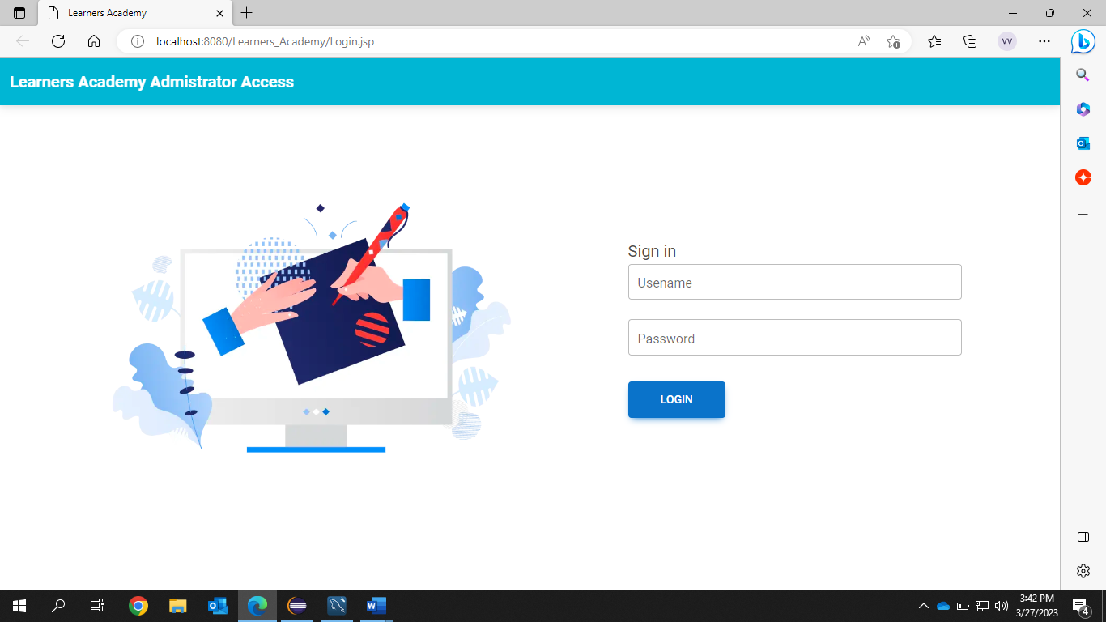

2.Admin page when entered invalid details

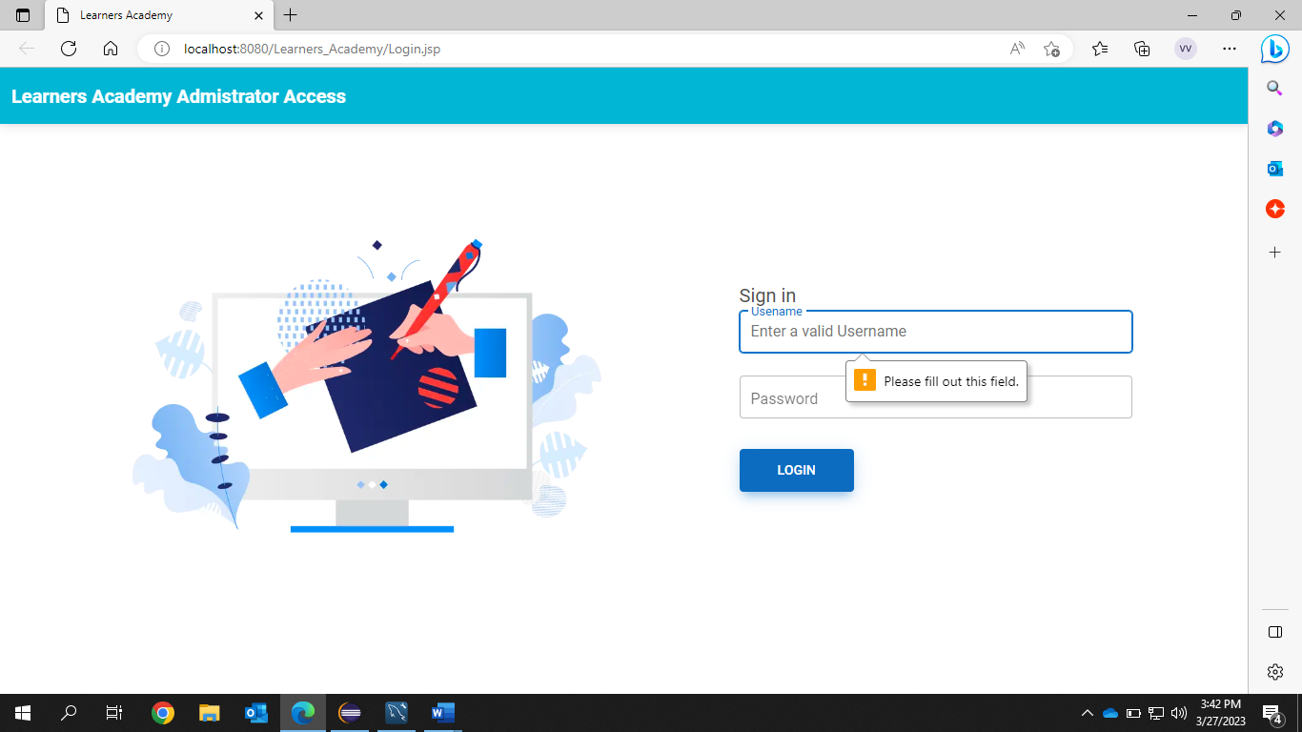

3.Students Master List

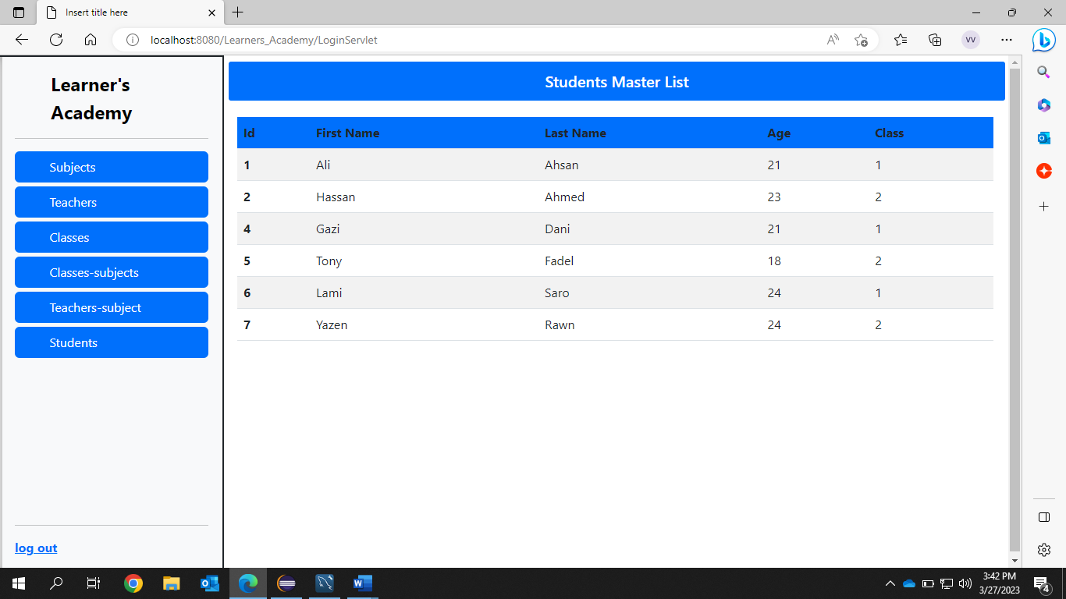

4.Subjects Master List

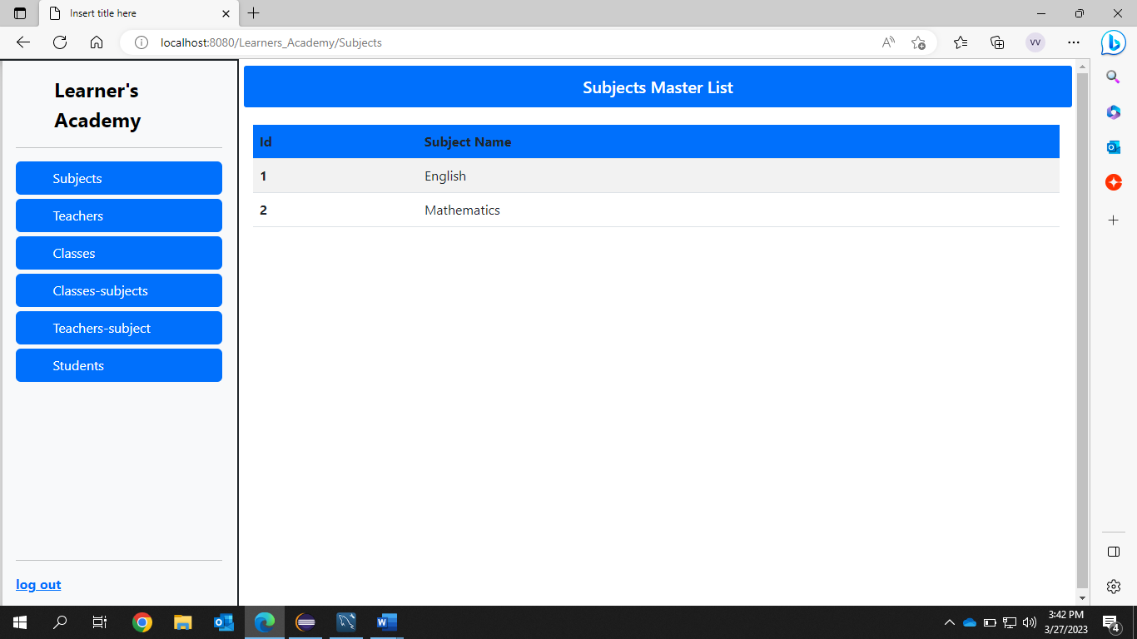

5.Teachers Master List

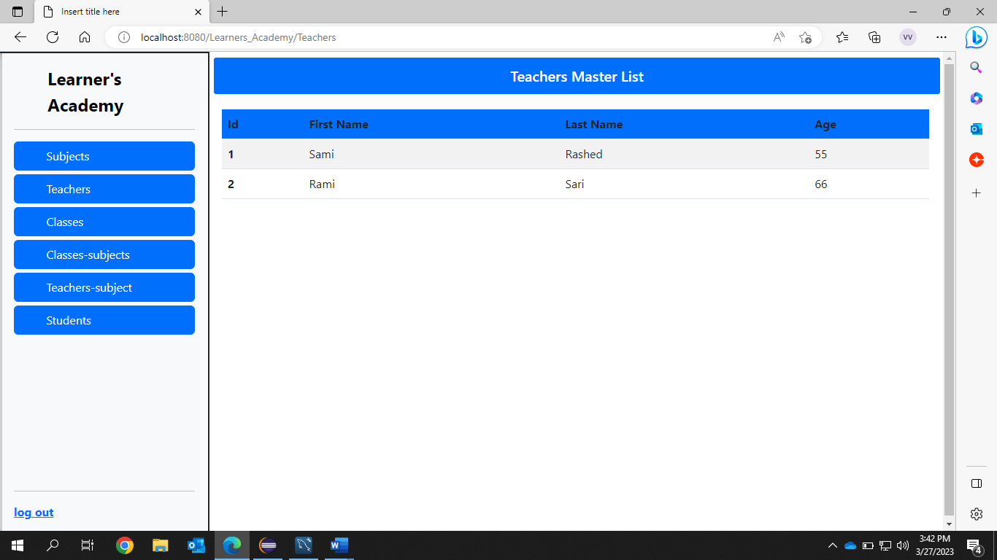

6.Classes Master List(Each column is retrieved using corresponding foreign key)

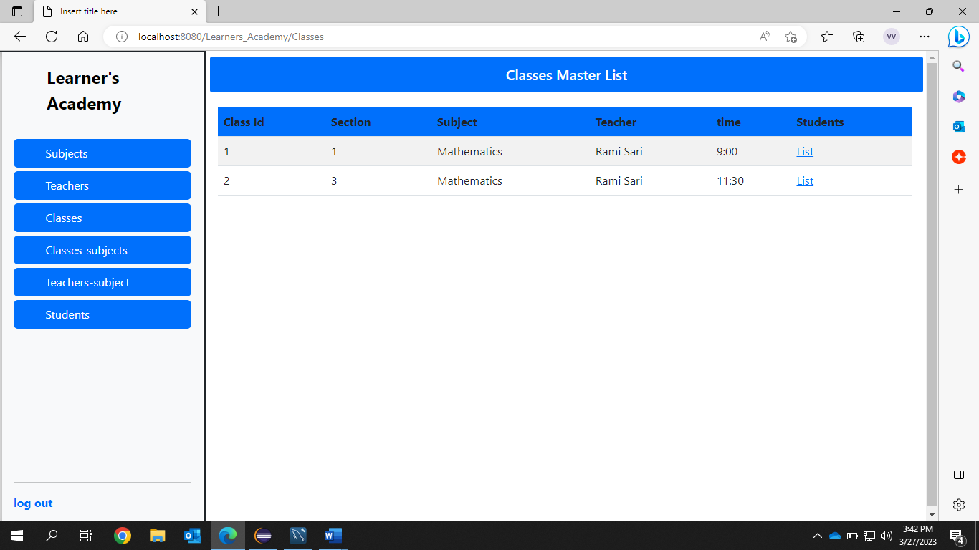

7.Students list of particular class selected in Class page

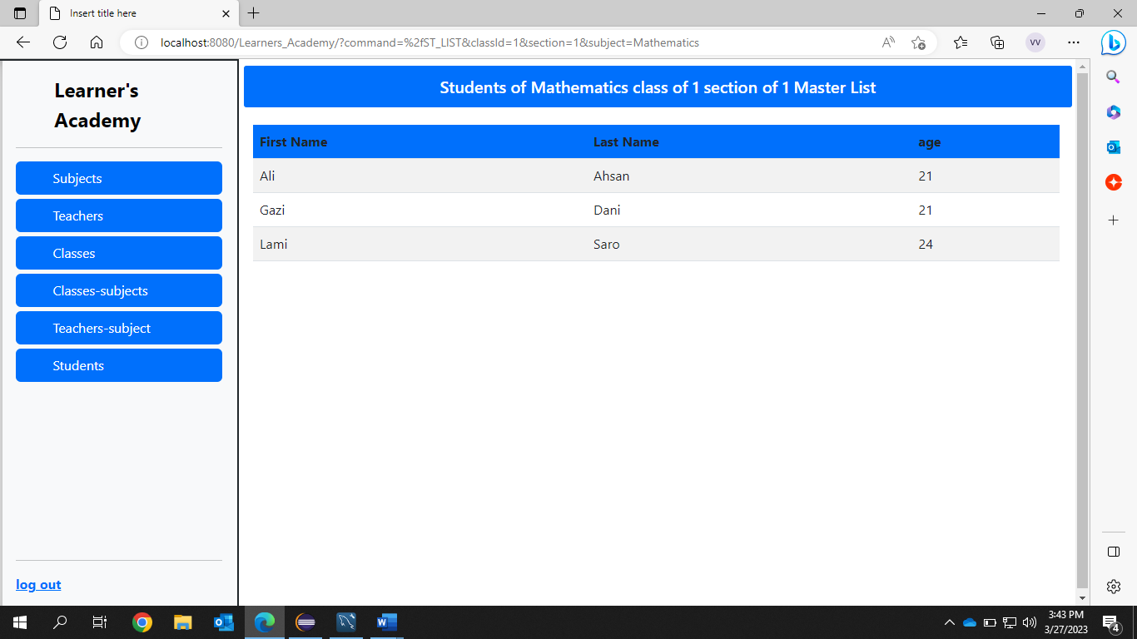

8. Assigning Classes-Subjects

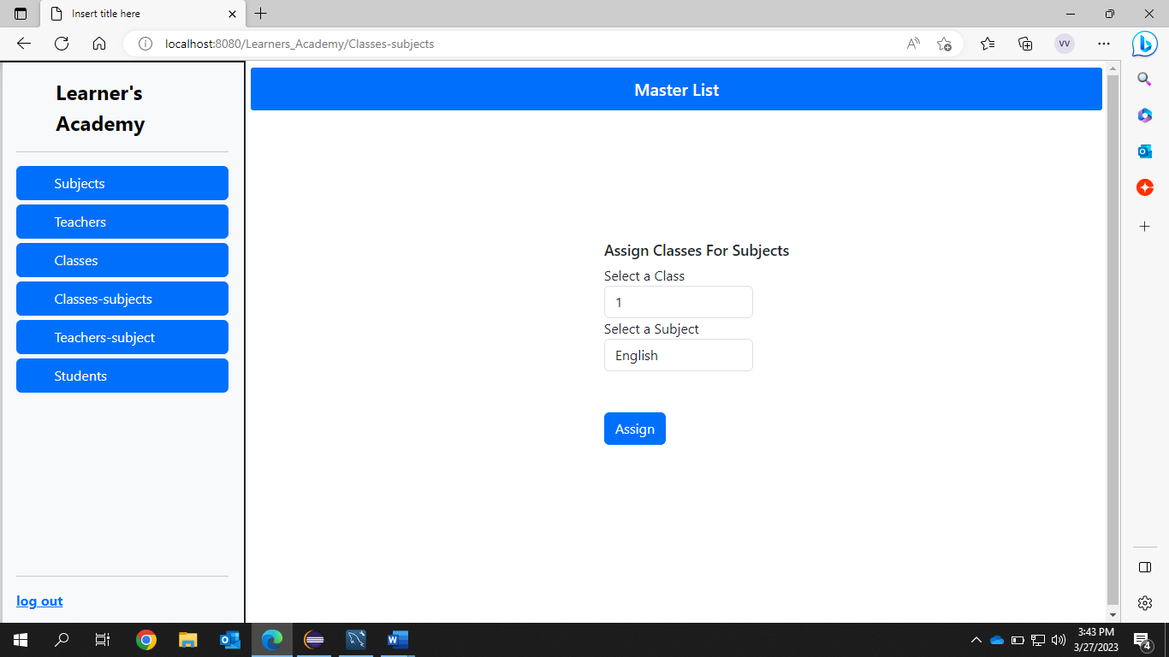

9.Classes-Subjects Assigned Successfully

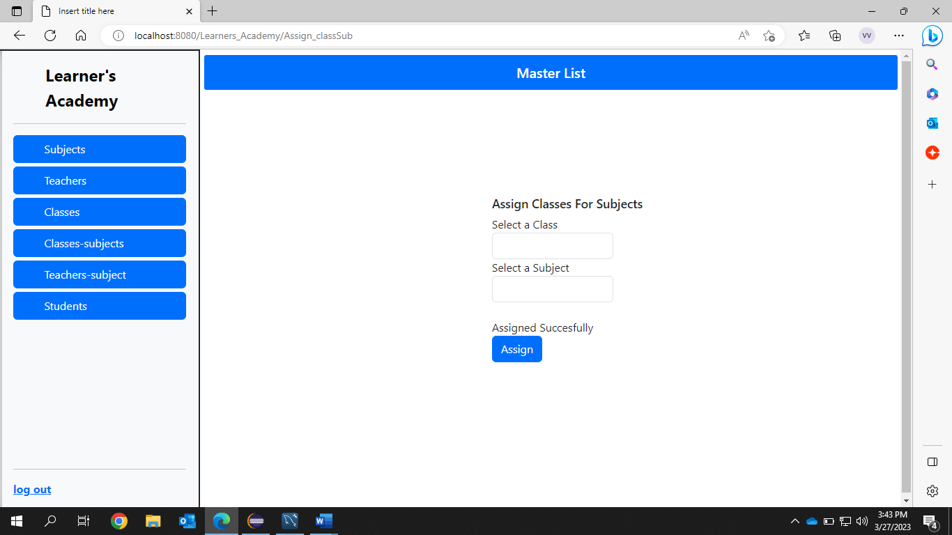

10.Assign Teacher to a class for a Subject

